# Installing R:

<https://cran.cnr.berkeley.edu/>

Choose your operating system and follow the prompts.

# Installing RStudio:

<https://rstudio.com/products/rstudio/download/>

Choose the free RStudio Desktop version.

# Get started without installing anything:

<https://rstudio.cloud/>

Free, for now… Sign up and start using on your browser.

# The basics: what are these 4 parts in RStudio?

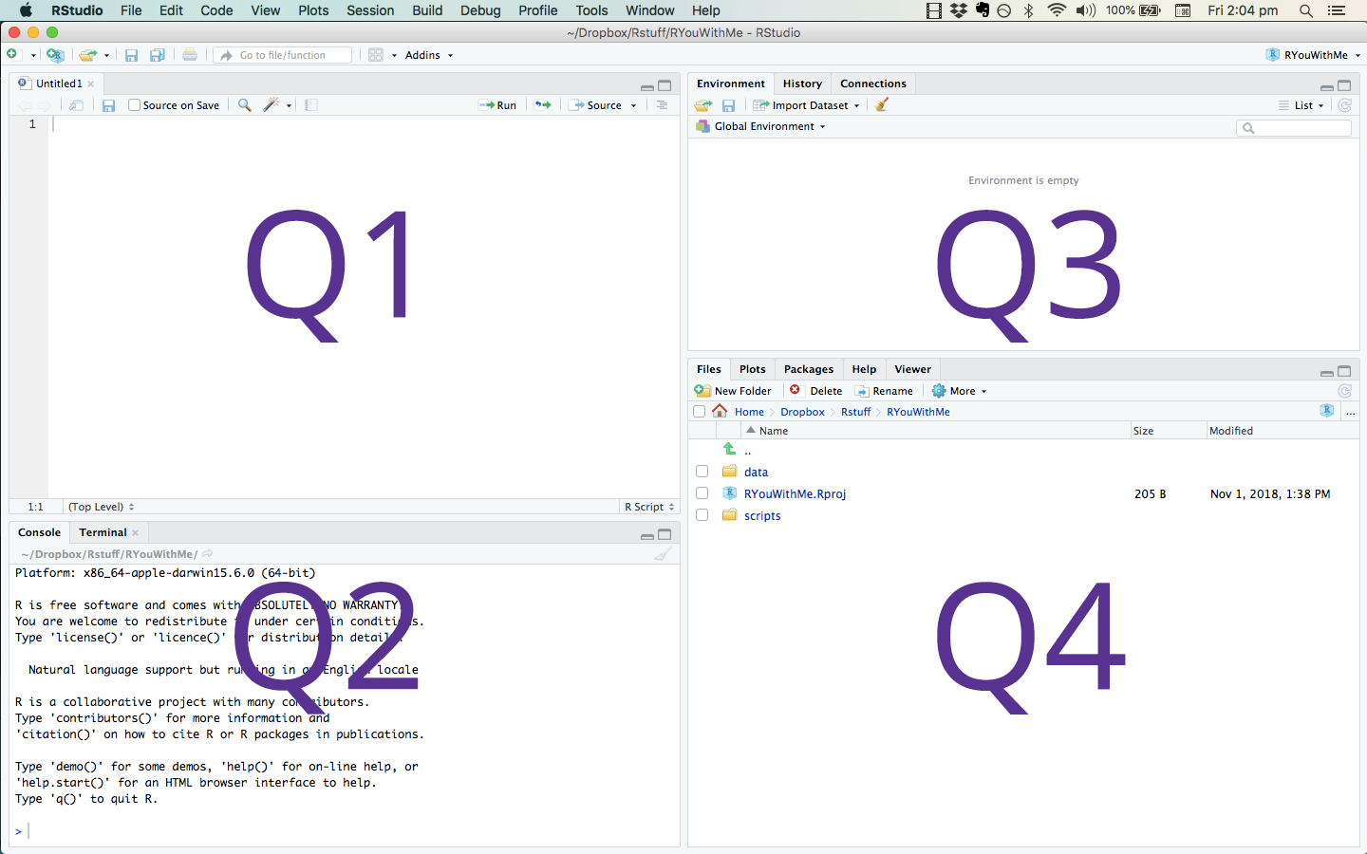

Q1 - script, data, **R Notebooks**

Q2 - console, terminal

Q3 - environment, history

Q4 - files, plots, packages, help

Adapted from: <https://rladiessydney.org/post/2018/11/05/basicbasics-1/>

# But how do I change the…

Font, size, color, order of the panels above, etc…

When in RStudio (or RStudio Cloud) click Tools >> Global Options, then just look through the options.

# Installing packages

Think of it likes apps on your phone that allow you to do different things depending on what strikes your fancy…

You can click the Packages tab (Q4 above), then Install (top left) and search for the packages by name.

Alternatively, you can use this R code in your console (Q2 above):

install.packages(“PackageName”)

For this to work you replace the PackageName part with the actual package name, but leave the quotes.

If you haven’t already, do this for a package called tidyverse.

# Always remember, at least while you learn:

Stay organized! Here are some of my opinionated tips.

Whenever you start something new, here are the steps to start with:

* Create a **new project** in a new or existing directory.
* Create a **new R Notebook** and make tons of notes on what you are doing. Trust me, you won’t remember tomorrow, much less in a month or so when you get back to the project. Now imagine if someone else has to use it… ;)

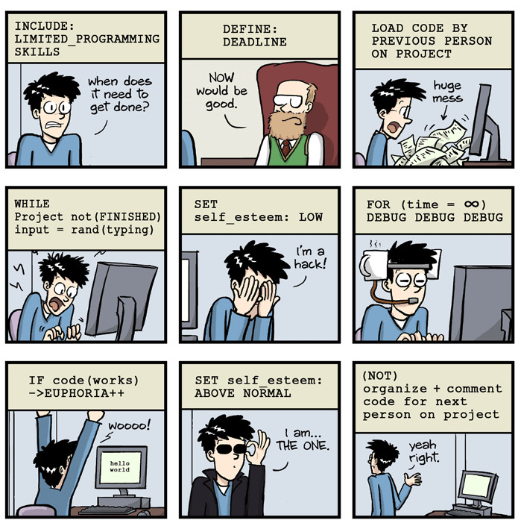Cartoon from PhD Comics

* Make the **1st R code chunk in your notebook and load all necessary packages** from here. The first one is likely to be the tidyverse.

# One final tip

Take the “copy, paste, and tweak” approach. Especially when you learn your first programming language or you need to understand particularly complicated code, it is often much easier to take existing code that you know works and modify it to suit your ends. This approach can also be useful once you’re familiar with programming. You can save snippets of code you use frequently and just reuse and tweak those.